Lazarus Beacon
Emergency Long-Range Survival Beacon for Autonomous Biosuits
Document Type | Proof-of-concept white paper
Concept Thesis | Divert a protected slice of suit reactor output into a long-range distress beacon when survival conditions are critical.
Primary Integration | Biosuit reactor + emergency telemetry + rescue localization
Status | Emergency subsystem concept draft
Abstract
Lazarus Beacon is an emergency-mode communications and localization concept for autonomous biosuits operating in hostile or post-biological environments. In normal operation, the suit preserves energy for survival, life-support, and local telemetry. In emergency mode, a protected reserve channel attenuates nonessential subsystems and redirects a controlled slice of reactor output into a long-range distress beacon. The beacon transmits suit identity, life-state, environment flags, and recovery telemetry in patterned bursts designed for search teams, relay meshes, or shipboard recovery systems. The aim is not to turn the entire suit into a constant high-power transmitter, but to make the suit strategically loud only when being found matters more than everything else.
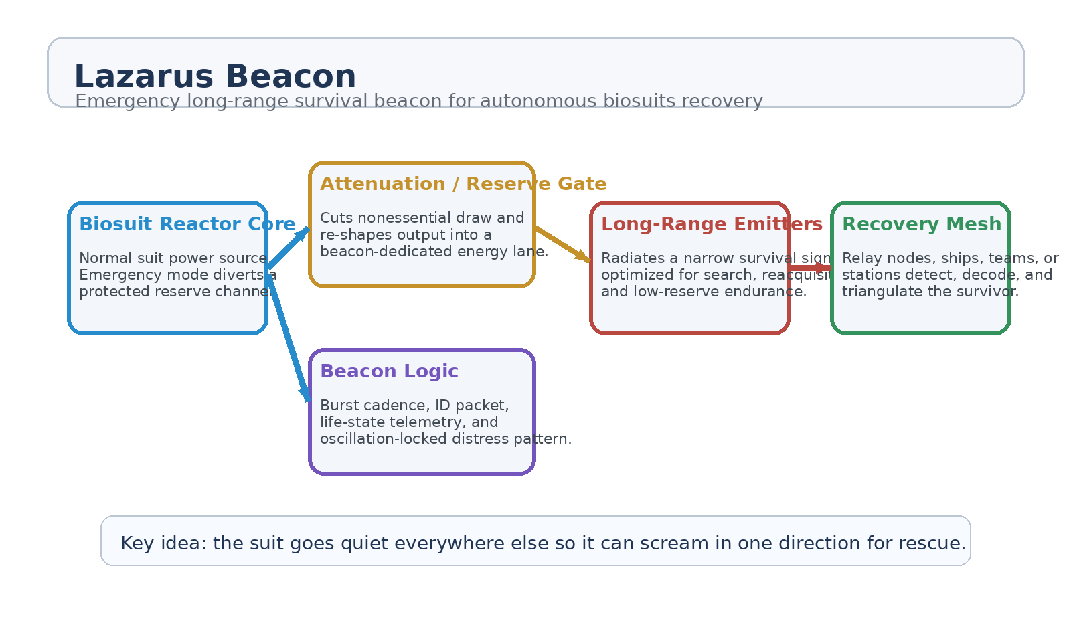
Figure 1. Lazarus Beacon architecture: reserve gate, beacon logic, and rescue-facing signal path.
1. Concept Thesis
A lost suit does not need to be globally expressive. It needs to be findable. Lazarus Beacon is based on the idea that a biosuit should maintain a normally quiet reserve mode until a critical event occurs, then collapse nonessential output and use the freed energy margin to emit a survival-focused distress signal.
This creates a disciplined emergency hierarchy: preserve life first, preserve signal second, and preserve everything else only if both of those remain stable.
2. System Architecture
Layer | Subsystem | Primary Function | Recovery Role
L1 | Suit Reactor Core | Primary suit power source under normal operation. | Provides the energy reserve.
L2 | Reserve / Attenuation Gate | Cuts nonessential draw and isolates a protected beacon channel. | Makes emergency output possible.
L3 | Beacon Logic Package | Builds burst cadence, identity packets, and life-state telemetry. | Structures the distress signal.
L4 | Long-Range Emitter | Radiates a focused or patterned rescue signal beyond normal suit range. | Makes the survivor detectable.
L5 | Recovery Mesh | Ships, relays, drones, or teams detect and triangulate the signal. | Converts emission into recovery action.

2.1 Reserve / Attenuation Gate
The reserve gate is the core survival decision point. It reduces or suspends nonessential suit functions, protects life-critical loops, and reroutes only a controlled slice of reactor output into the beacon subsystem. In other words, the suit does not become a reckless floodlight. It becomes selective, intentional, and recoverable.
• Keep oxygen and thermal survival loops above the beacon in priority.
• Collapse nonessential diagnostics, comfort systems, and routine networking when needed.
• Shift from continuous transmission to burst mode if reserves fall below threshold.
• Preserve enough energy margin that the beacon does not kill the wearer while trying to save them.
2.2 Beacon Logic and Telemetry
The transmitted packet should stay narrow and rescue-oriented. A distress signal is strongest when it carries only what matters for rapid reacquisition.
• Suit identity and class
• Life-state / biometric summary
• Last known heading or motion trace
• Environment hazard flags
• Oxygen reserve state
• Reactor reserve estimate
• Time-since-trigger or emergency-stage status
2.3 Burst Pattern Strategy
A constant maximum-power broadcast is usually worse than a patterned one. Burst emission allows the suit to preserve reserves, create a distinctive rescue signature, and give relay systems a cleaner timing pattern for reacquisition and triangulation. The beacon can therefore run in escalating tiers: low-duty cycle search mode, medium-duty lock mode, and high-urgency rescue mode when immediate pickup is likely.
3. Operating Modes
• Normal mode: suit communications remain local and low-draw; Lazarus Beacon stays dormant.
• Emergency trigger mode: trauma, separation, signal loss, suit breach, or prolonged immobility activates the reserve gate.
• Search mode: low-duty long-range bursts prioritize endurance and broad detectability.
• Lock mode: once recovery assets acknowledge the signal, cadence shifts to improve triangulation and refine location quality.
• Terminal preservation mode: if reserves collapse, the signal narrows to minimal ID and life-state packets at the longest survivable interval.
4. Why It Fits the Biosuit Stack
Lazarus Beacon integrates naturally with biosuit reactor and autonomy concepts because those systems already assume a sealed survival shell, adaptive emergency behavior, and strong local control over energy allocation. The beacon is therefore not an unrelated radio bolted to the armor. It is an emergency survival behavior emerging from the same suit logic that already handles oxygen, thermal regulation, and hostile-environment persistence.
5. Proof-of-Concept Build Path
Phase | Goal | Bench Activity | Success Signal
P1 | Reserve channel test | Demonstrate that nonessential suit loads can be attenuated while critical survival loops remain stable. | Safe emergency power diversion.
P2 | Beacon packet demo | Build a minimal ID + life-state distress packet and emit it in controlled bursts. | Readable rescue payload.
P3 | Range extension test | Compare normal suit telemetry range to Lazarus Beacon emergency range under controlled conditions. | Meaningful long-range gain.
P4 | Burst endurance mode | Test multiple duty cycles and reserve thresholds to maximize findability without collapsing survival reserves. | Predictable endurance profile.
P5 | Recovery exercise | Use receivers or relay nodes to detect, reacquire, and triangulate the beacon from a simulated lost-suit scenario. | Successful localization workflow.

6. Measurements
• Emergency range increase relative to normal suit comms.
• Energy cost per distress burst and per hour of beacon operation.
• Localization accuracy at different burst cadences.
• Survival-loop stability while beacon mode is active.
• Time to first acquisition by rescue mesh or relay node.
• Minimum viable beacon interval under depleted reserve conditions.
7. Safety Boundaries
The suit must never spend its last breath on theater. Lazarus Beacon only works if the energy hierarchy is strict and the beacon cannot cannibalize life-critical loops without limit.
• Oxygen delivery, thermal regulation, and medical preservation outrank the beacon.
• Beacon output must step down automatically if survival reserves approach floor thresholds.
• Signal logic should degrade gracefully to minimum viable identity packets rather than full collapse.
• False-trigger suppression is essential so the system does not waste reserves during recoverable noncritical events.
8. Integration Opportunities
• Rescue drones and relay buoys that listen specifically for Lazarus Beacon cadence patterns.
• Shipboard recovery consoles that fuse beacon data with suit biometrics and hazard overlays.
• Squad tracking modes where emergency beacon logic activates only after normal team comms fail.
• Post-impact search systems for zero-visibility, submerged, buried, or radiation-obscured survivors.
9. Conclusion
Lazarus Beacon is a clean emergency subsystem because it gives the biosuit a simple, disciplined survival behavior: go quiet everywhere else so rescue can hear you farther away. By diverting a protected slice of reactor output into a burst-based, telemetry-rich distress pattern, the suit becomes recoverable without abandoning the primacy of life support.
The system therefore belongs naturally inside any advanced autonomous biosuit stack that intends not only to keep the wearer alive, but to make sure someone can still find them.
Working one-line doctrine: The suit goes quiet everywhere else so it can scream in one direction for rescue.

